Assignmnet:1

**1)Write brief description about unit testing and functional testing and it’s benefit in project, as a developer perspective?**

* It is a type of software testing where individual units or components of a software are tested. It is done during the development of an application. Unit testing isolates a section of code and verify its correctness.
* It can also be defined as testing technique using which individual modules are tested to determine if there are any issues by the developer himself.

Benefits of unit testing:

1. Reduces defects in newly developed features or reduces bugs when changing the existing functionality.
2. Reduce cost of testing as defects are solved in early phase.
3. Improves design and allow better refactoring of code.
4. Gives the quality of build when integrated with build.

Functional Testing:

* Functional testing is defined as type of testing that verifies that each function of the software application operates in conformance with the requirement specification. This testing mainly involves black box testing and it is not concerned about the source code of the application. It focuses on manual testing as well as automation testing.

Functional testing involves checking of the following:

* User Interface
* API
* Database
* Security
* Client/Server applications
* Functionality of the Application Under Test

Benefits of Functional Testing:

* This testing provides a replica of what the actual system is i.e., it is replica of what the product is in the live environment.
* It does not work on any assumptions about the structure of the system.
* It ensures the delivery of high quality product which meets the customer requirements.
* It ensures to delivery a bug free product.

2.**Where and why do you need unit testing in your project, give me 10 example and code snap?**

* Improve the design of implementations.

Start coding a feature without giving it a lot of thought to the design is a very common mistake among developers. Using unit testing is going to enforce you to think and re-think the design, and if you are using TDD the impact is even bigger.

* Allows refactoring.

Since you already have tests that ensure that everything is working as expected, you can easily add changes to that code with the certainty that you are not adding any bugs.

* Add new features without breaking anything.

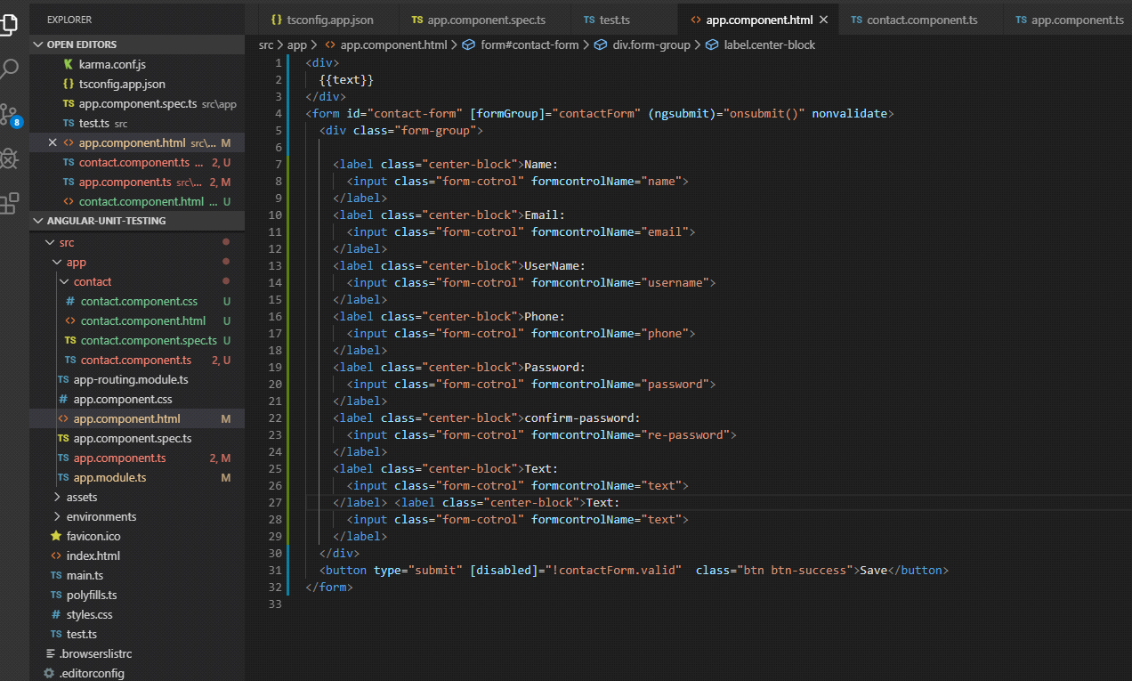When you are adding a new feature you can run the tests to ensure that you ain’t breaking any other part of the application.

Example:

1. form is invalid.
2. form is valid.
3. Email is in valid format.
4. password is compare confirm-password.
5. mobile number in 10 digit
6. password is in 1 uppercase letter and 1 special character
7. User name is require a special character
8. text is contact page
9. set submitted true
10. call onsubmit method